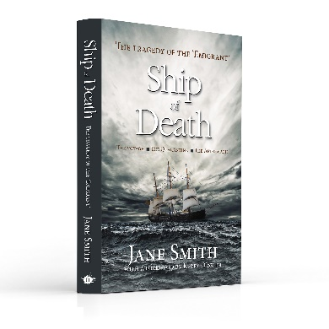 | BOOK CLUB QUESTIONS: SHIP OF DEATH  - Ship of Death tells the story of people threatened by a deadly disease in a time when medical science was less evolved than it is now, and yet in the years since it was published we have experienced the challenges of a deadly pandemic. How have your experiences of the Covid-19 pandemic and all the issues surrounding it (like infection control and quarantine measures, and medical and government responses) affected your reading of the text?  - Which character(s) did you feel the most sympathy for and why? Whose stories interested you the most? Why?  - What were some of the most surprising things you learnt about conditions on the voyage?  - Our understanding of the prevention and treatment of disease has come a long way since 1850. Which developments do you think have been the most significant and which are you most grateful for?  - If you’d been on the voyage of the Emigrant and survived it, how do you think it might have affected your attitude to life?  - Even though they had survived a terrible ordeal on the Emigrant’s voyage, the Maunsells later sponsored their families’ emigration to Australia. Does that surprise you? If you had been in their position, would you have encouraged your families to do the same?  - The stories of some of the passengers who came out on the Emigrant’s 1850 voyage provide a snapshot of early white settlement in Australia. Are there any similar stories in your own family’s history? Were they success stories, like some of the stories of those who became prominent and well-respected citizens, or were they stories of ongoing hardship?  - The ship’s surgeon, George Mitchell, was only 25 when he took on responsibility for the health, welfare and discipline of the passengers and crew of the Emigrant. Do you think his youth would have been an advantage or disadvantage in his situation?  - The children of two families on the Emigrant were orphaned in the ordeal. How did you react to the stories of their fates? What did you learn about the conditions in the orphanages, and how did that affect you?  - Ship of Death is written in a narrative non-fiction style – that is, it is a factual account, but uses techniques of fiction writing like descriptive passages and quoted dialogue to ‘flesh out’ the story and bring characters to life as much as possible given the information available. Do you think it achieved its objective in bringing the story to life while sticking to the truth?  For more information about the book and the author, visit:  www.theemigrant.weebly.com  www.janesmithauthor.com
SHIP OF DEATH
by Jane Smith

When 276 poor British emigrants sail from Plymouth on the ship Emigrant in April 1850, seeking a better life in Australia, they know nothing of the ordeal that lies ahead. For four terrible months they endure cramped and squalid conditions, insufferable heat, bitter cold ... and a mounting death toll from the dreaded disease raging through the ship: typhus.

When Emigrant arrives in Moreton Bay, the nightmare continues. For three long months in quarantine at Stradbroke Island, the immigrants' hopes are raised and dashed, and raised and dashed again.

Ship of Death unfurls the true saga of the voyage, quarantine and aftermath, revealing the human stories and bringing to life a remarkable journey common to many of Australia's early settlers.
Their stories are tales of hardship, resilience, courage and despair.

‘Jane Smith, excellent historian that she is ... has added a rich vein to our understanding of the personal, individual legends of early white settlement in Queensland.’ - Kerry O'Brien

SHORTLISTED for the Frank Broeze Memorial Maritime History Book Prize 2022.

